|  |  |  |
| --- | --- | --- |
| |  | | --- | | Discrete Structure Assignment Probability | |  |   **Dr. Muhammad Ahmad** |

|  |
| --- |
|  |

**National University of Computer & Emerging Sciences Department of Computer Science**

**General Guidelines**

1. Peer plagiarism and the late submissions are strictly not allowed

2. Total Marks: 100

3. Your assignment submission must be in hardcopy (i.e., handwritten, or printed form)

4. Deadline (As mentioned on Google Classroom)

# Question No 1(3)

Three dice are rolled simultaneously the probability of the sum being 3 is?

1/6*1/6*1/6= 1/216

https://www.youtube.com/watch?v=-BjPNGu8RN8&list=WL&index=167&t=906s&ab_channel=ExaminersView

# Question No 2(5)

25% of people like vegetarians.

80% of people like broccoli.

40% of meat eaters like broccoli.

What is probability that a man who likes broccoli is vegetarian?

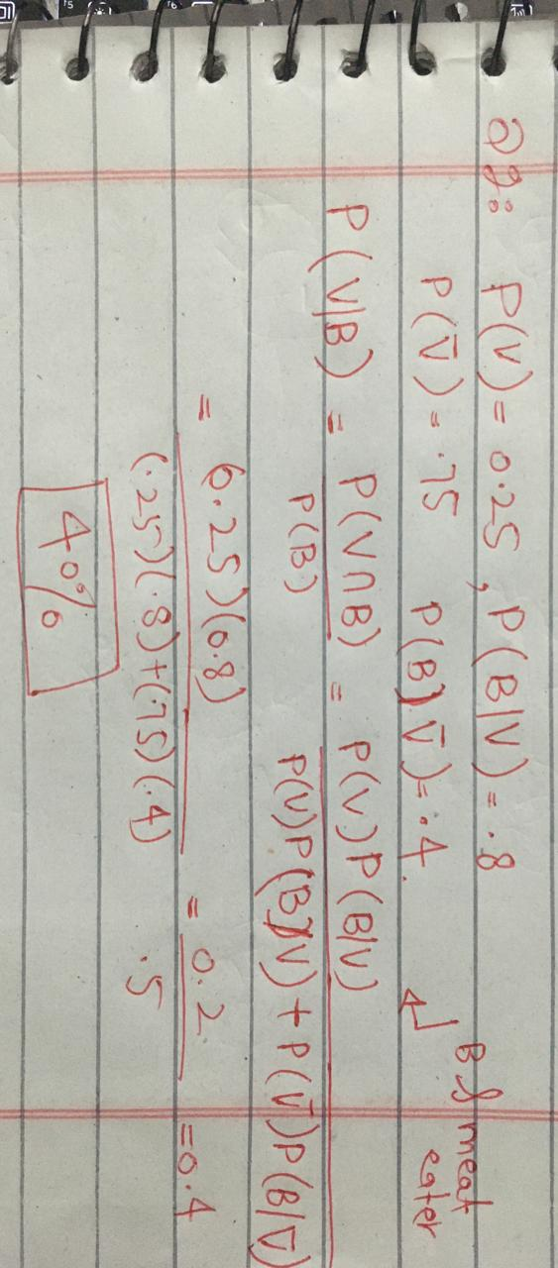

# Question No 3(3)

A coin is loaded so P(H) = 2/3 and P(T) = 1/3. It is tossed twice.

A: 1st is a tail.

B: Both are same

Determine A and B are independent or not? Explain.

# Question No 4(3)

A = {x: x N, x < 6}

B = {x: x N, 4 < x < 10}

Use Bayes’ theorem to find P(A / B).

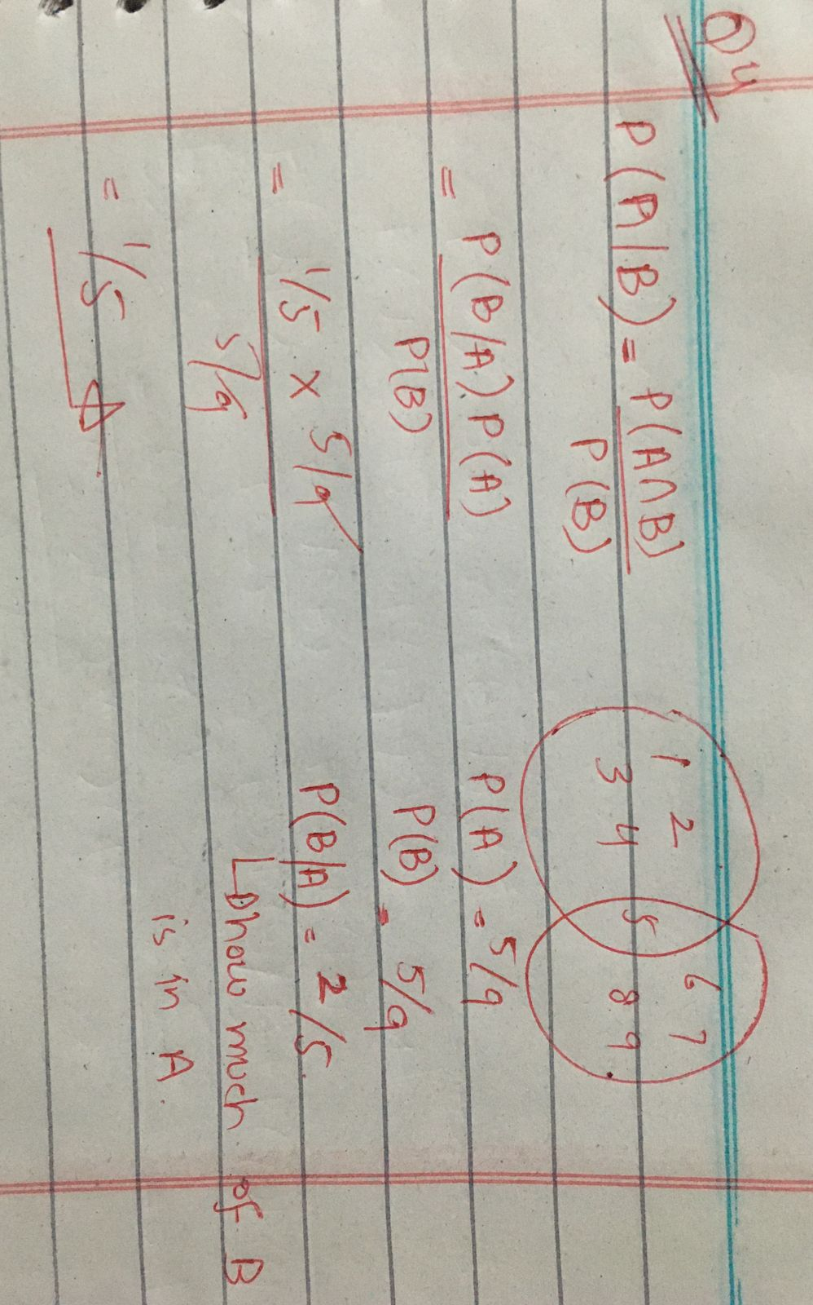

# Question No 5(4)

Container I incorporates 2 tape balls and 3 footballs. Container 2 incorporates 4 tape balls and 1 football.ContainerIII incorporates 3 tape balls and 4 footballs. A cube having 3 pink, 2 yellow and one greenface, is thrown to choose the container. If pink face turns up, we select up container I, if a yellow face turns up we select up container II, otherwise, we select up container III. Then, we randomly pick a ball from the chosen container. If the ball drawn is tape ball, what’s the probability that the cube had become up with a pink face?(Using Bayes’ Theorem).

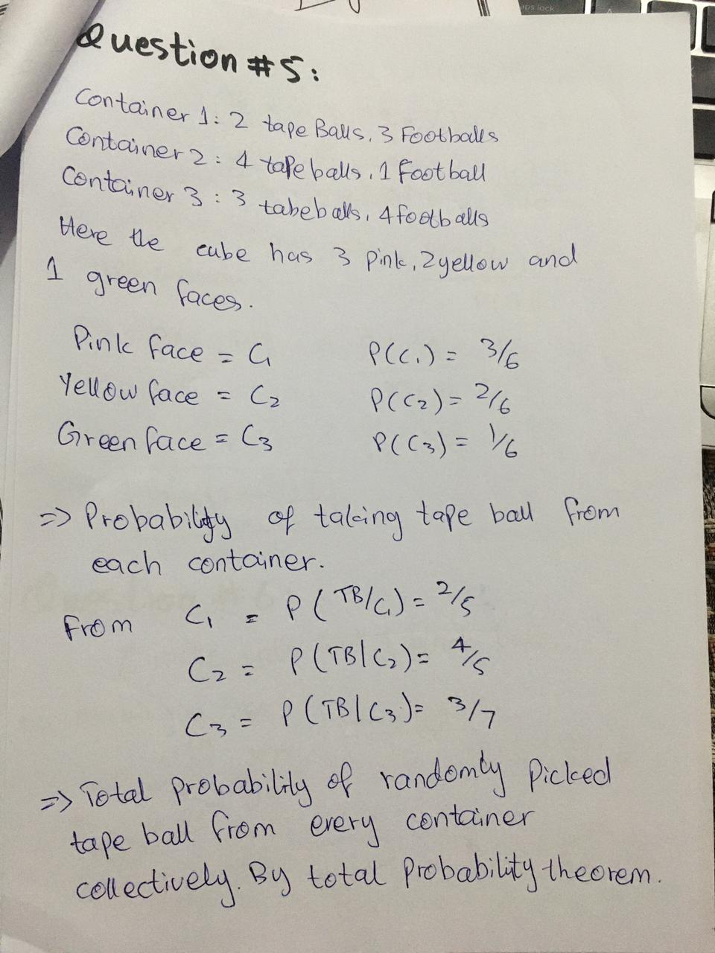

# Question No 6(3)

A bag contain 6 white and 4 black balls.

Two balls are randomly selected from the bag what is probability that they are of same color?

=> (6c2 + 4c2)/ 45 =7/15 (proper solution)

OR

6/10*5/9+ 4/10*3/10= 7/15

# Question No 7(5)

(Probability Tree)

Cameraman has a bag of counters. In the bag there are 3 red counters and 4 blue counters.Cameraman takes 2 random counters from the bag.

What is the probability that both counters are of the same color?

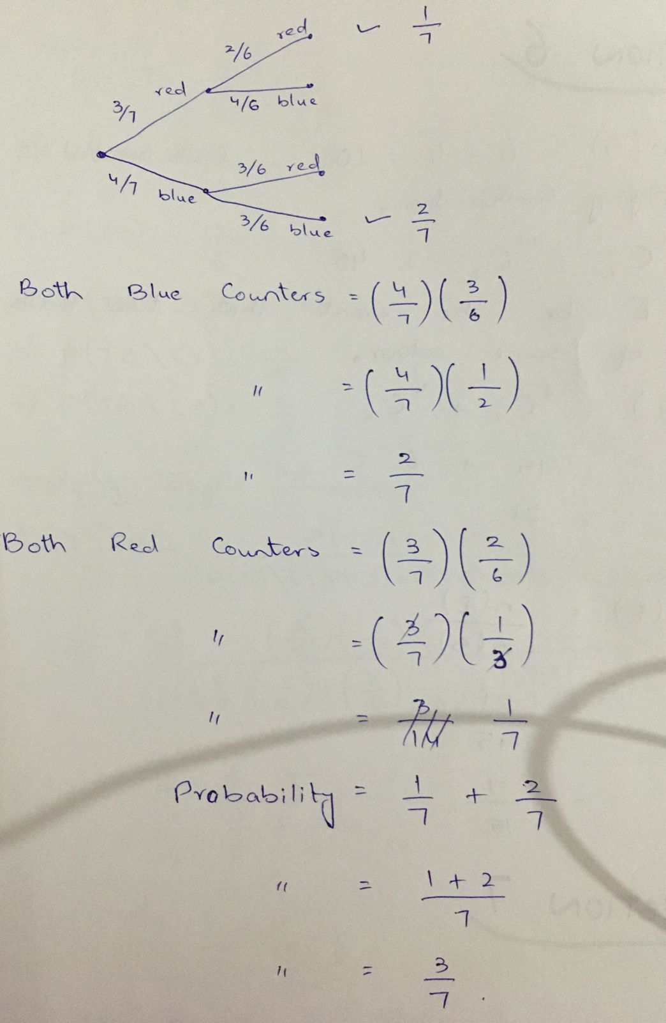

# Question No 8(5)

(Probability Tree)

A girl has 20 biscuits in a tin. She has 12 plain biscuits, 5 chocolate biscuits and 3 ginger biscuits.She picks 2 biscuits from tin.f

Calculate probability that they are not of same type.

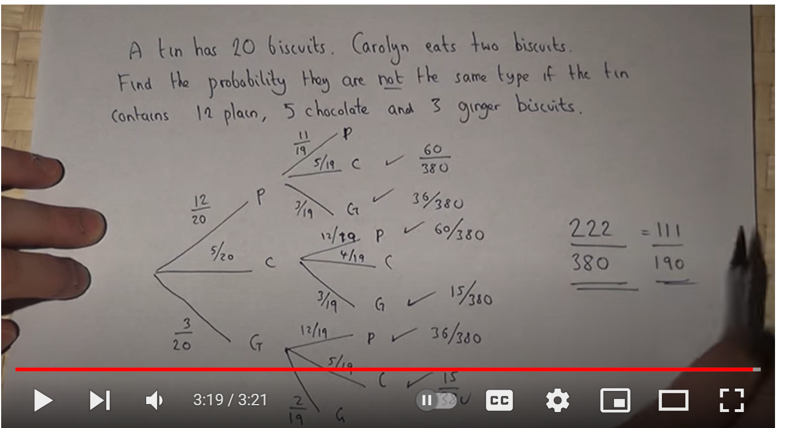

# Question No 9(7)

In a group of 8 students what is the probability that

1. Nobody has a birthday on the same date.
2. At least 2 have birthdays on the same date.
3. Exactly 2 have same birthday.
4. Exactly 3 have same birthday.
5. 4 or 3 have same birthday.
6. At most 3 have same birthday.

# Question No 10(5)

Use Law of Total Probability

A production house owns three machines. Machine I, machine ii and machine iii, produces 25%, 30% and 40% of output. 5%, 4% and 2% of the output are observed to be defective. Worker draws a random product from the production. What is the prob of product being defective?

https://www.doubtnut.com/question-answer/in-a-bolt-factory-machines-a-b-and-c-manufacture-respectively-25-35-40-of-the-total-of-their-output--648121532

# Question No 11(3)

If we throw a pair of dice what is the probability of getting a total more than 7?

5/12

(Proper solution with possible outcomes written)

# Question No 12(3)

Two unbiased coins are tossed what is the probability of getting at most one head?

possible outcomes/total = ¾

https://www.youtube.com/watch?v=_agzJJS4vjc&list=WL&index=168&t=427s&ab_channel=MalikTutorial

# Question No 13(4)

One card is drawn from a pack of 52 card. What is the probability of the card being either a red card or a king?

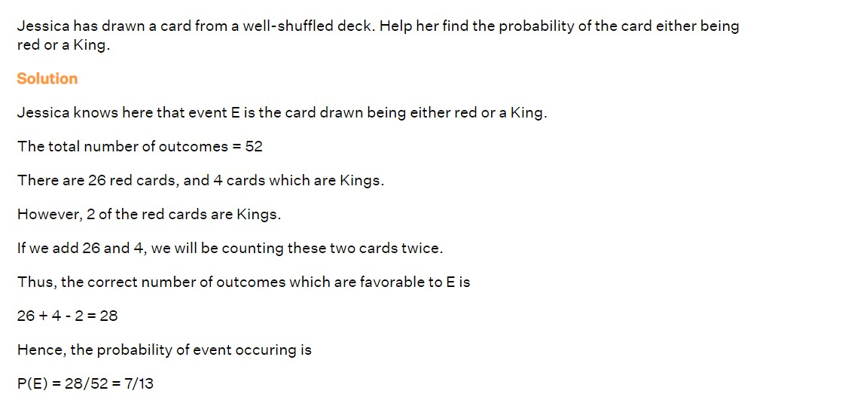

# Question No 13(3)

If five letters

K, L, B, C, A are arranged

What is the probability of the arranged word being ‘BLACK’?

1/120 (PROPER SOLUTION)

# Question No 14(5)

Ali can hit a target 3 times in 4 shots

Shahzaib 2 times in three shots and

Uzair 5 times in 6 shots

What is the probability that none of them will hit the target?

ali=3/4, shahzaib= 2/3 uzair=5/6,

1/4*1/3*1/6= 1/72

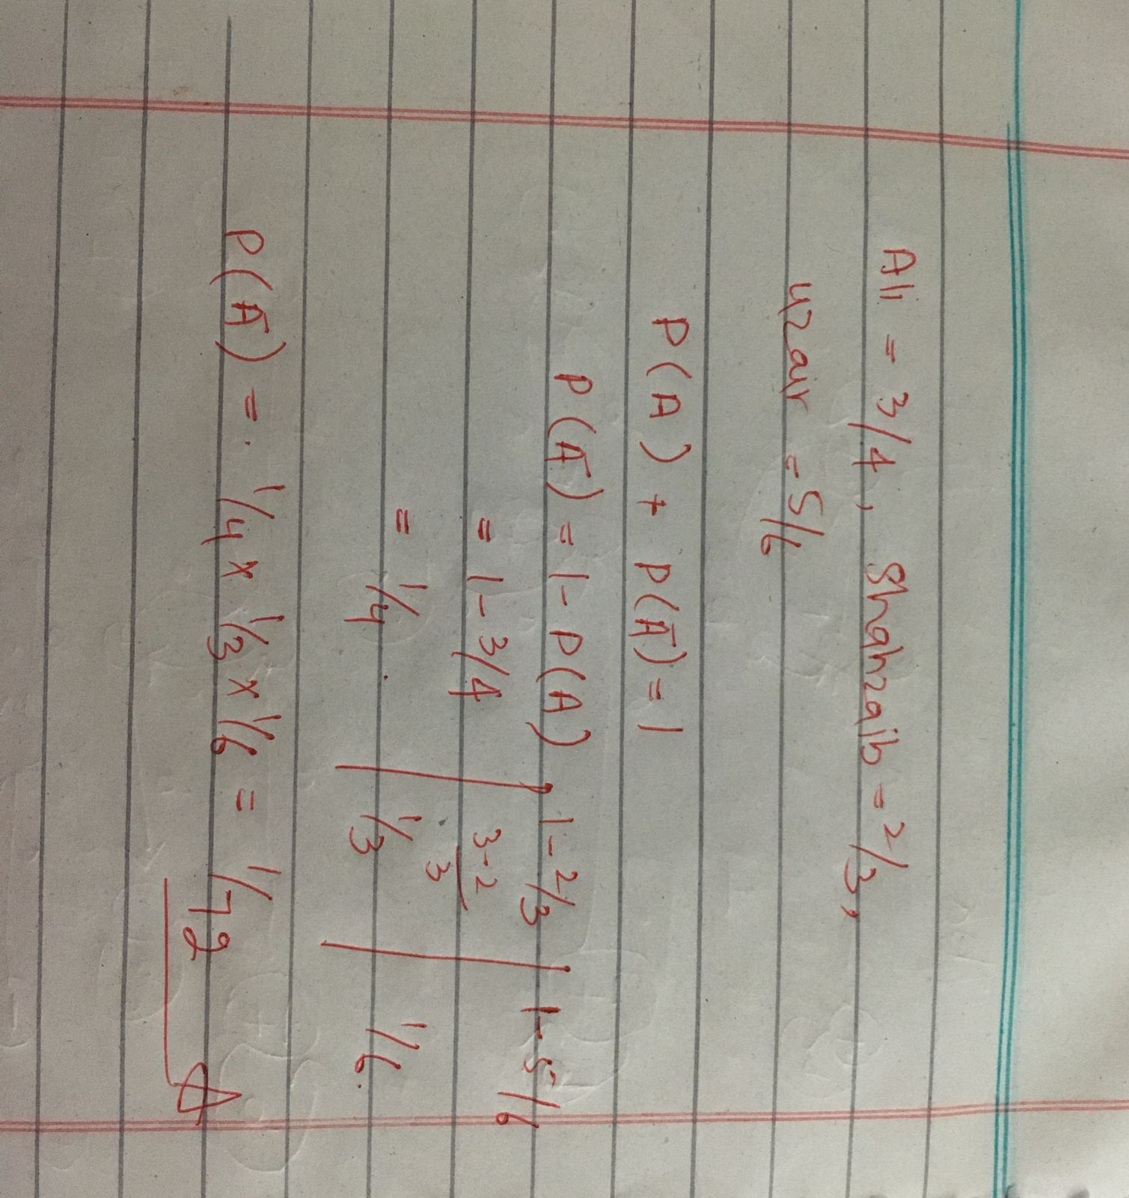

# Question No 15(4)

A box contains 3 footballs

4 cricket balls

5 volley balls

Three balls are drawn in succession with replacement. What is the probability of the three being volley balls?

5/12*5/12*5/12(PROPER SOLUTION)

# Question No 16(5)

(Probability Tree)

If Fiona prepares her energy drink in the morning. She has an 80% probability of being on time for her fitness class. If she does not prepare her energy drink, the probability that she is late to her fitness class in 60%.

Fiona prepares her energy drink every 5 out of 7 days.

1. What is the probability that Fiona is on time for her fitness class?
2. If Fiona tries to go to her fitness class 150 times a year, how many times is she on time?

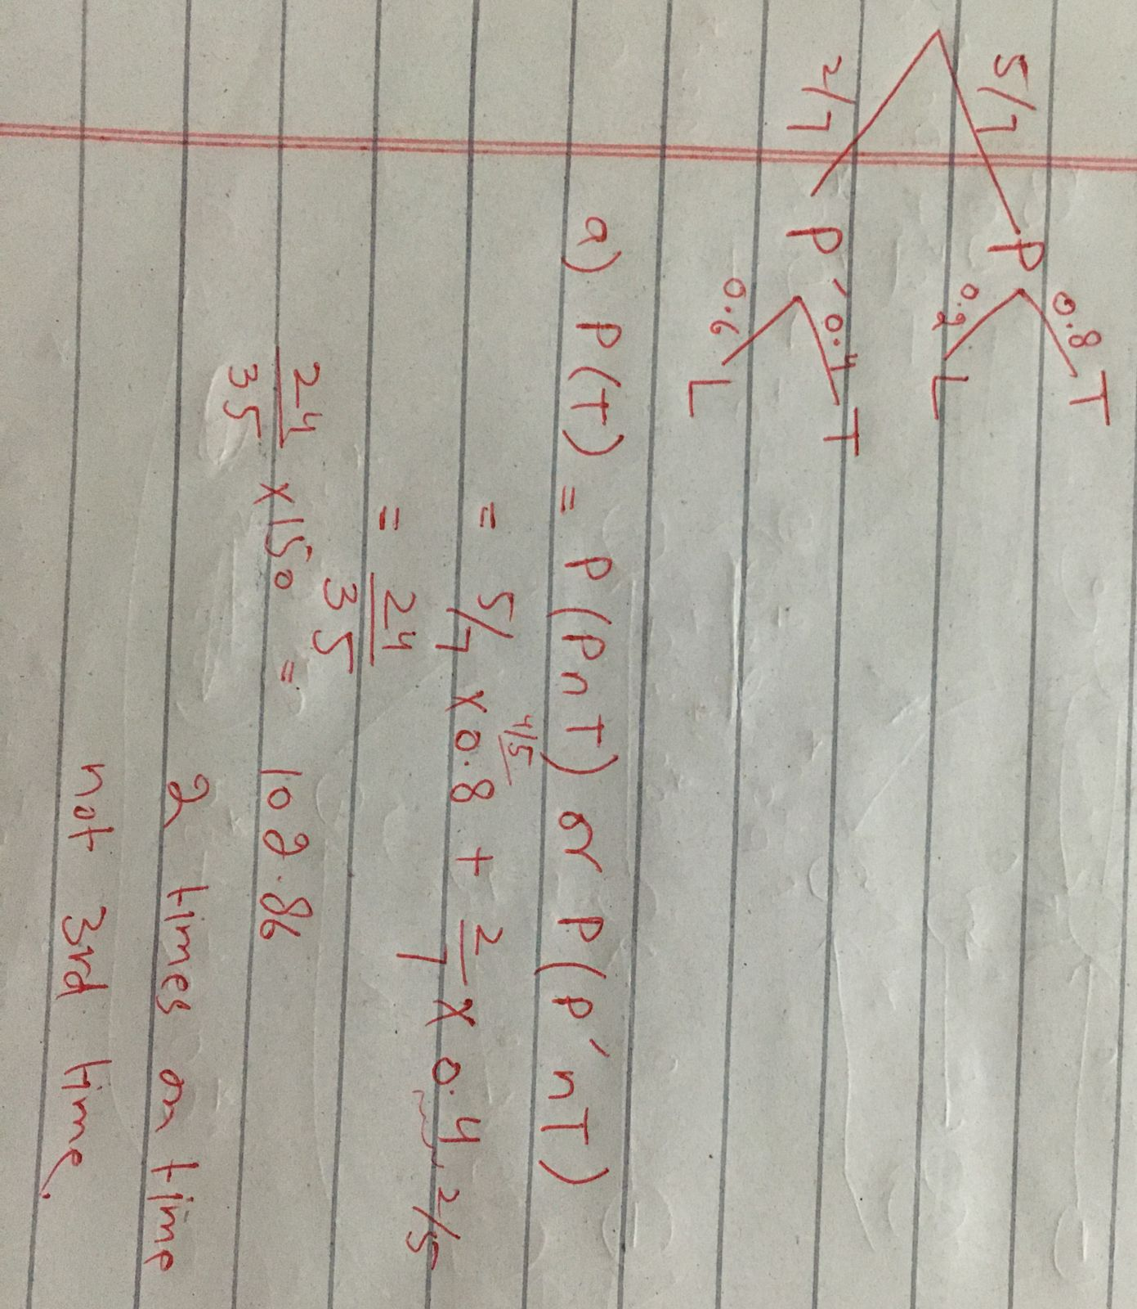

https://youtu.be/yYvFwdKpNPM